Lab 05 SCD
L1F23BSSE0372
Muhammad Arham

Question # 01 Correction:
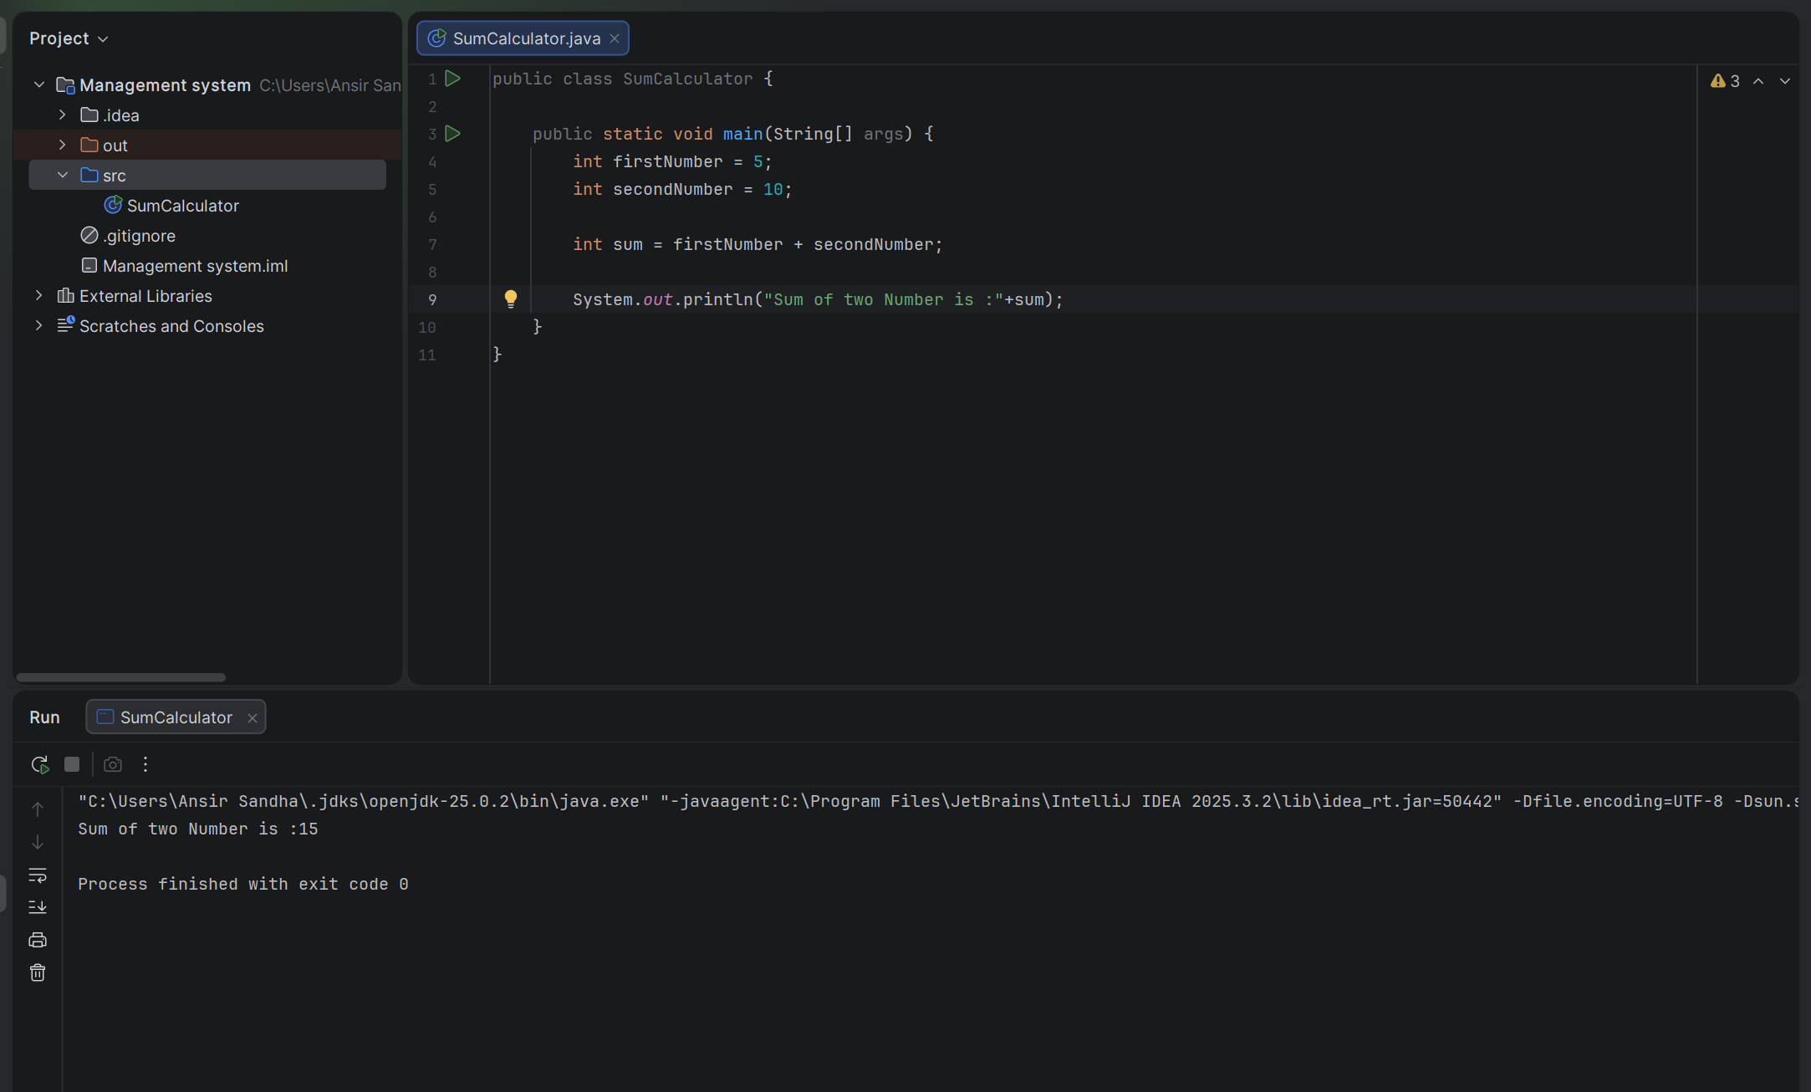
Meaningful names
Proper spacing
Clean structure

Question # 02 Correction:
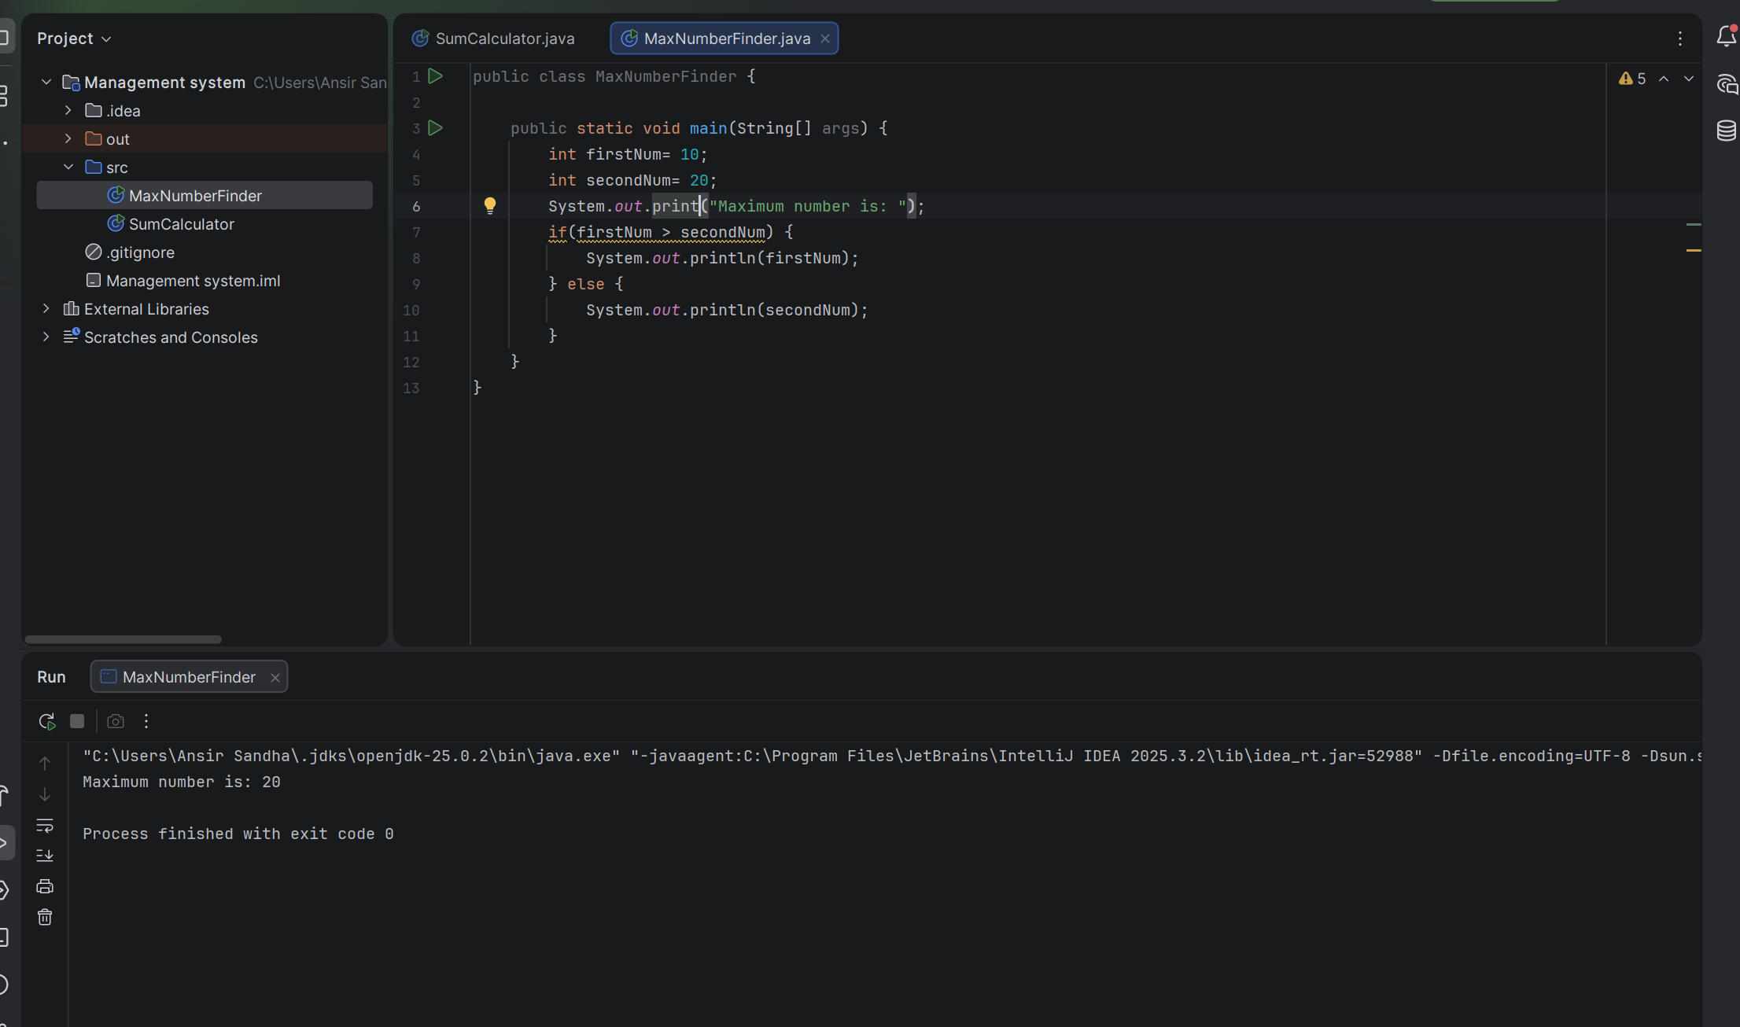
Added braces {}
Improved readability
Question # 03 Correction:
Issues:
Class name p is meaningless
Variables n, f, i not descriptive
No comments explaining logic
Poor formatting (everything cramped)
No input validation (negative numbers)
Question # 04 Correction:

Issues:
- Class name A not meaningful
- Multiple statements on one line
- Variables x, y unclear
- No spacing
- Poor readability
Question # 05 Correction:
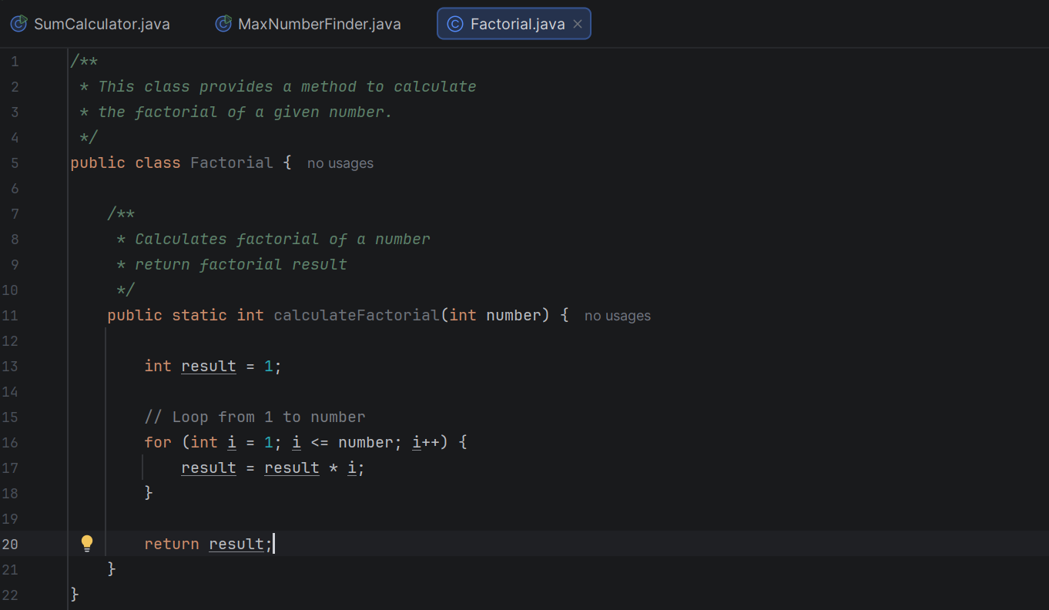

Question # 06 Correction:
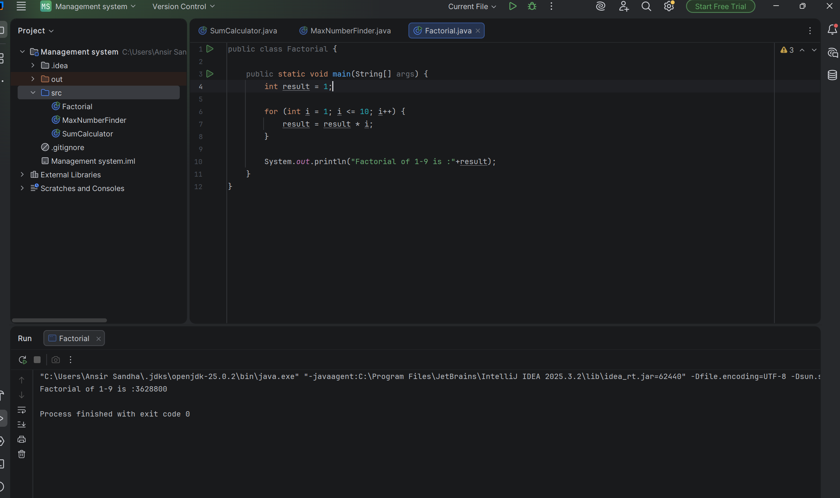

Proper spacing
Clear structure

Question # 07 Correction:

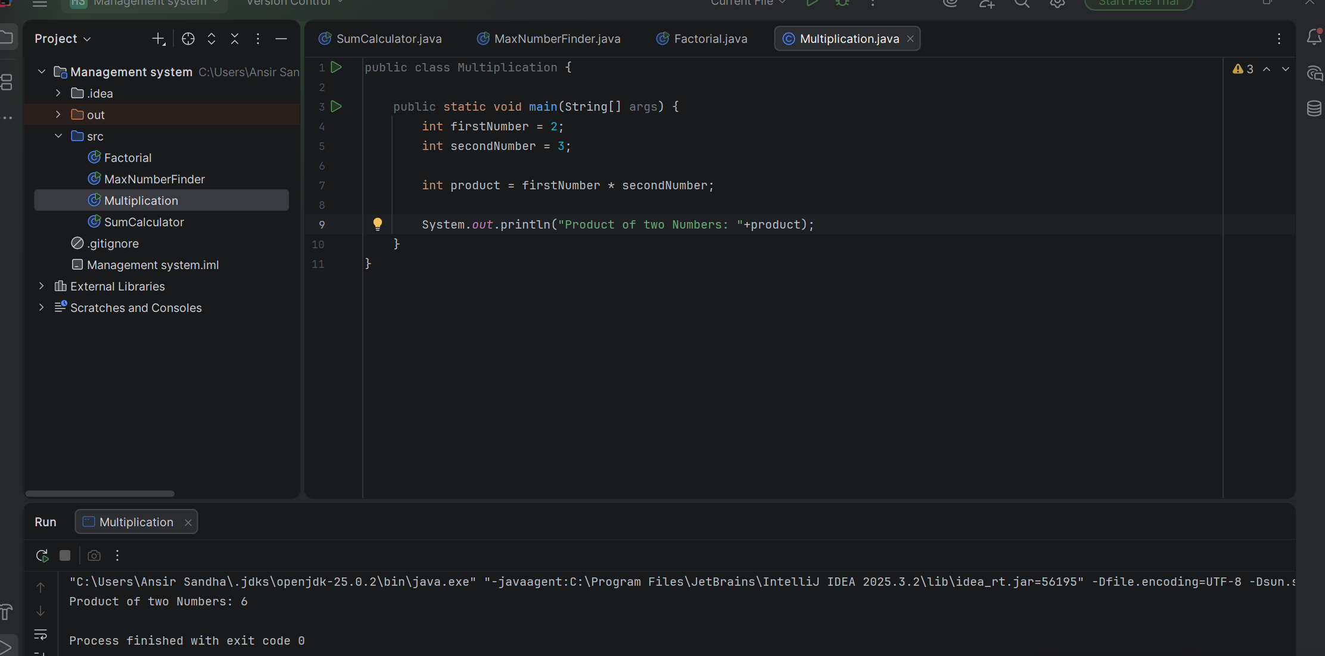

Question # 08 Correction:
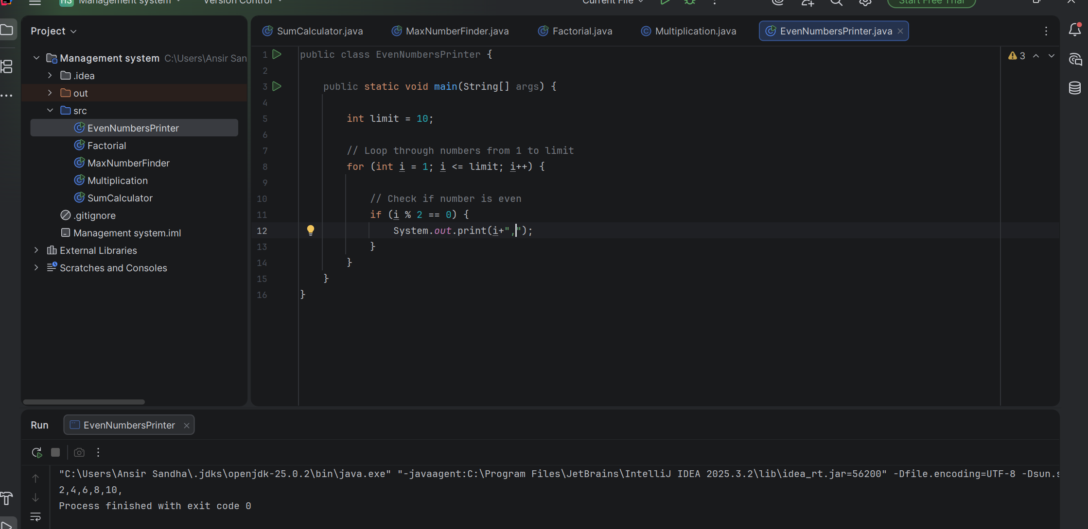

Question # 09 Correction:
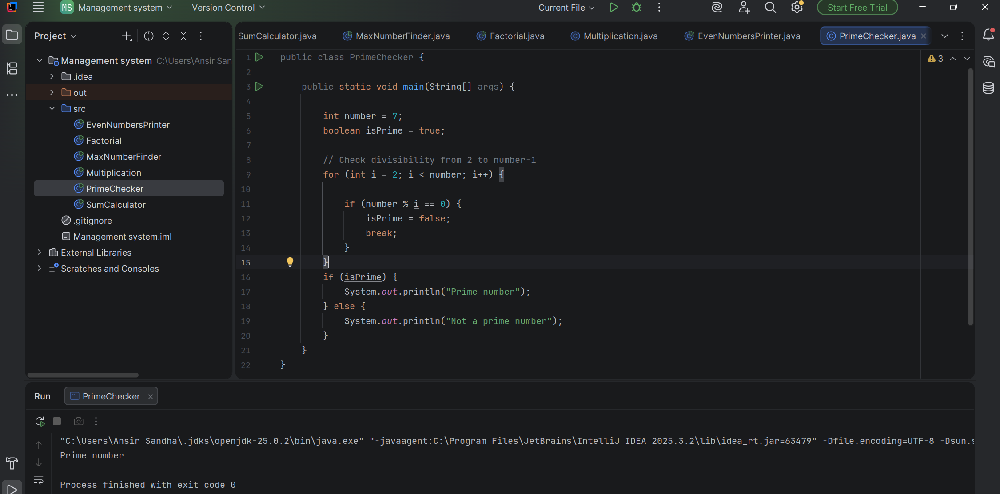

Question # 10 Correction:
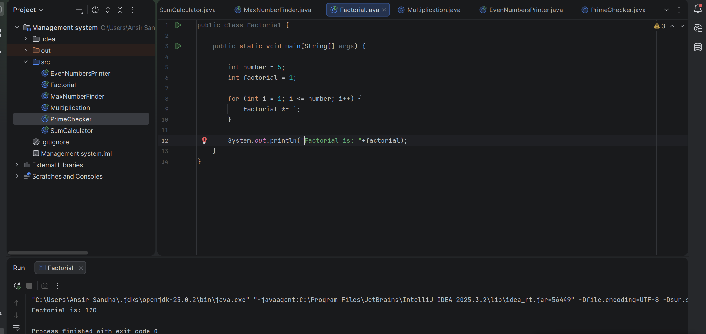

Issues:
- Class name z meaningless
- Variable a unclear
- No comments
- Hardcoded value (5)
- No method (not reusable)
- No validation
- Poor naming
Question # 11 Code:
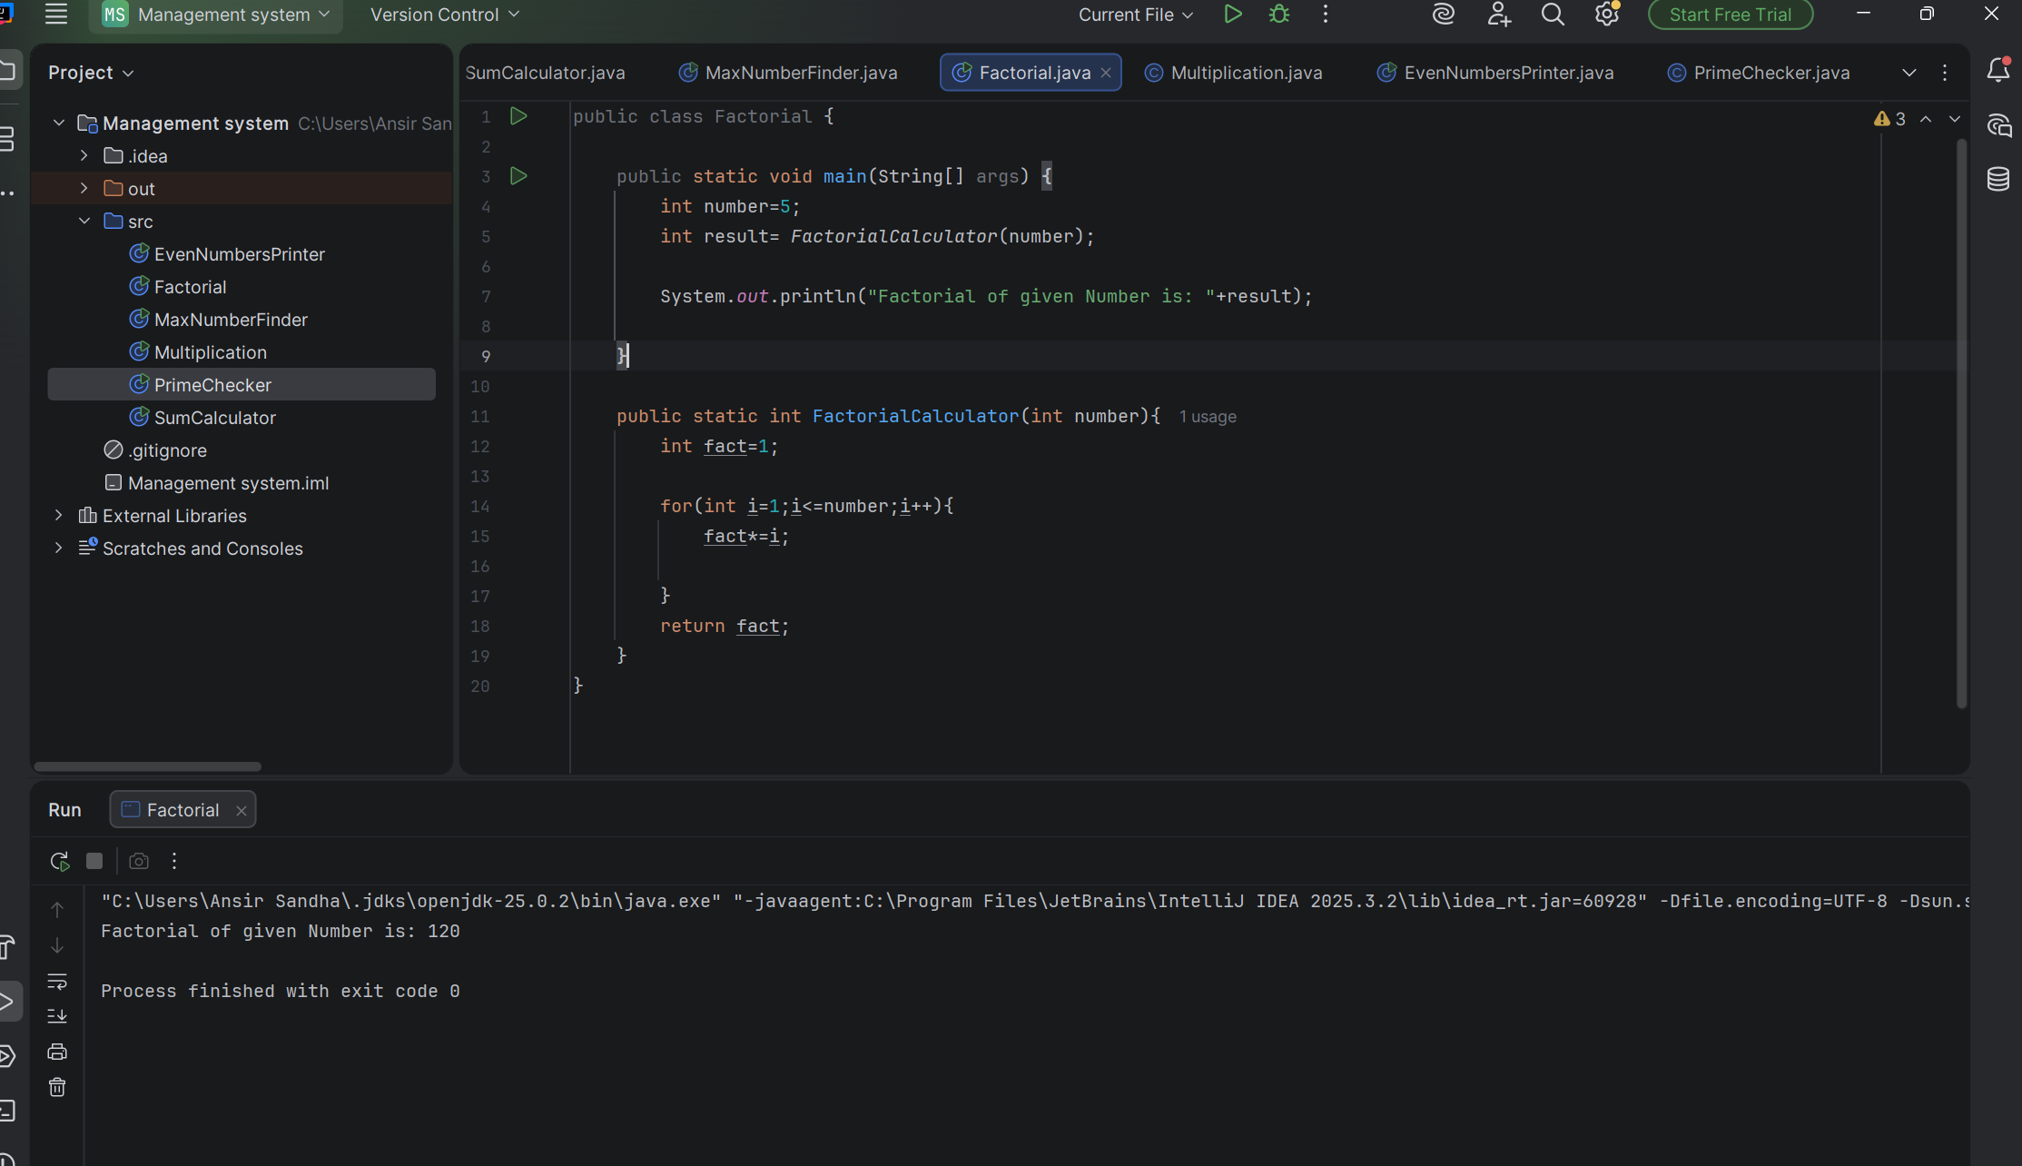

Question # 12 code:

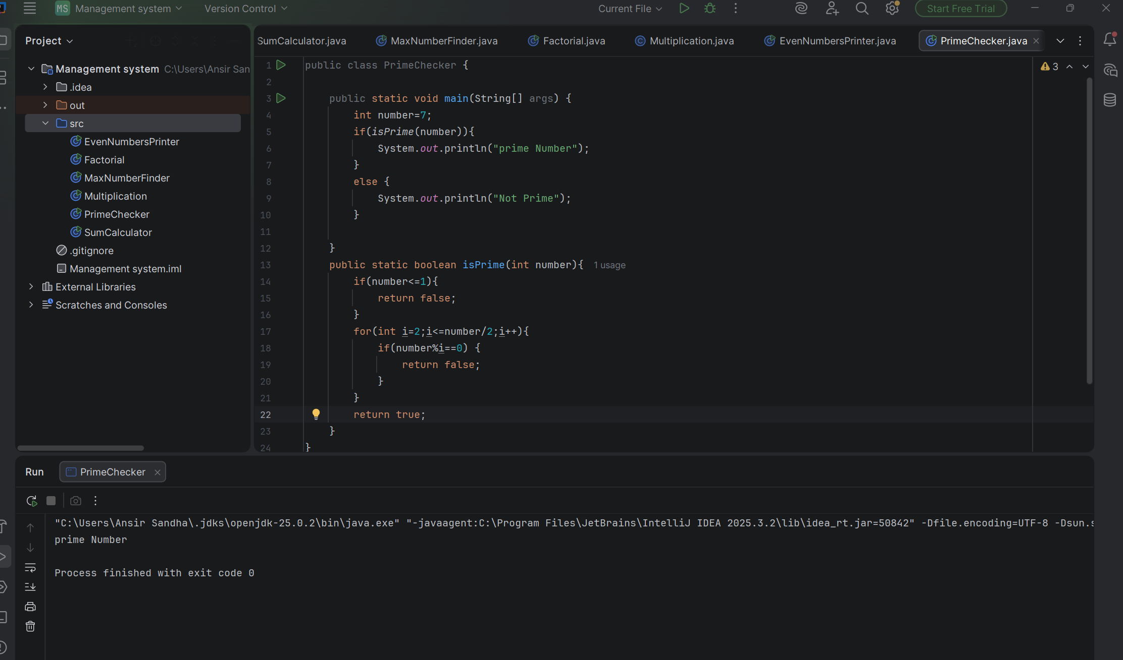

Question # 13 Code:




